Ninebot F series FAQ
K049-202103-007V1

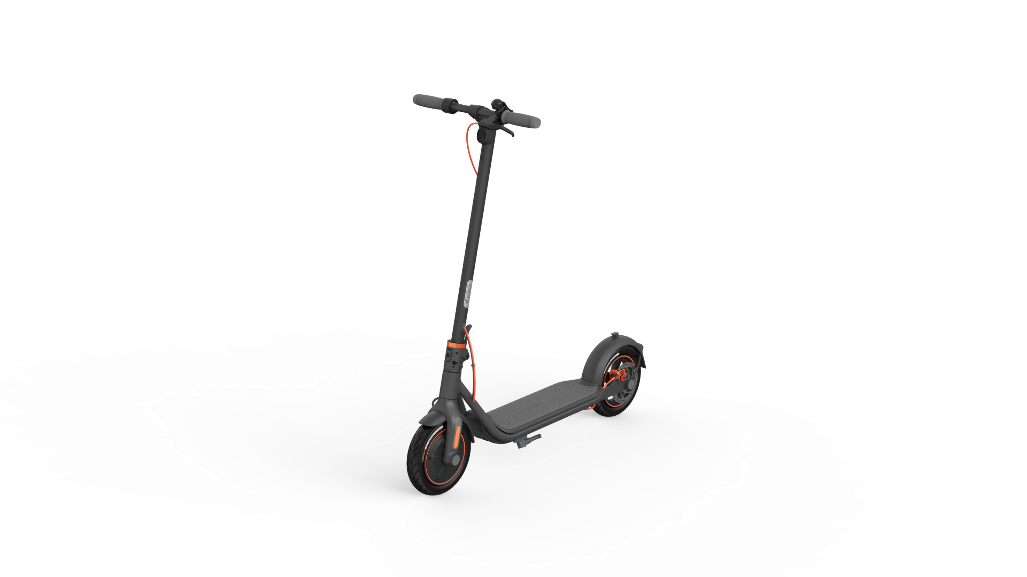

Catalog
1. Product Introduction 8
1.1 Product Positioning： 8
1.1.1What is Ninebot F scooter？ 8
1.1.2 How many models does Ninebot F series scooter has？ 8
1.1.3 Who is the Ninebot F series scooter for? 8
1.1.4 What is differences between F20/F25/F30/F40?，Which one is more suitable to buy？ 8
1.2 Product Parameter 9
1.2.1 What is parameter of Ninebot F20？ 9
1.2.2 What is parameter of Ninebot F25？ 9
1.2.3 What is parameter of Ninebot F30？ 9
1.2.4 What is parameter of Ninebot F40？ 10
1.2.5 What is charge time of Ninebot F series scooter？ 10
1.2.6 What is difference between F20 and F25？ 10
1.2.7 What is motor power of Ninebot F series scooter？ 10
1.2.8 What is battery nominal capacity of Ninebot F series scooter ？ 10
1.2.9 What is size of front/rear wheel ？ 10
1.2.10 What is tire pressure of Ninebot F series scooter？ 11
1.2.11What is payload of Ninebot F series scooter ？ 11
1.3 Product advantages: Compared with similar products, what is advantage of Ninebot F series scooter？ 11
1.4 Usage scenarios: usage scenarios and precautions of Ninebot F series scooter？ 11
2. Quick Start 12
2.1 How to install and adjust? 12
2.1.1 How to install Ninebot F series scooter？ 12
2.1.2 How to adjust disc brake？ 13
2.1.3 How to inflate scooter? 13
2.1.4 How to solve brake disc friction problem？ 14
2.2 How to use： 15
2.2.1How many speed mode?How to change speed mode？What is MAX speed？ 15
2.2.2 What is difference between different speed mode？ 15
2.2.3 How to ride scooter? 16
2.2.4 How to activate scooter? 18
2.2.4 Does it have to be activated to use scooter？ 18
3. Function introduction 18
3.1 Light 18
3.1.1 How to open and close headlight 18
3.1.2 How to open/close taillight? 19
3.2 Power on/off、brake、charge 19
3.2.1 How to power on? 19
3.2.2 How to power off? 19
3.2.3 How to use brake 19
3.2.4 How to charge? 19
3.3 Folding and Carrying 20
3.3.1 Folding 20
3.3.2 Unfolding 21
3.3.3 Carrying 21
3.4 APP 21
3.4.1APP How to connect APP? 21
3.4.2 How to open cruise mode? 22
3.4.3 How to adjust energy recovery? 22
3.4.4 How to use APP lock and unlock scooter 23
3.4.5 How to bind scooter? 24
3.4.6 How to do owner certification? 24
4. Common problem classification 25
4.1 Frame problem： 25
4.1.1 What kind of tires are used in Ninebot F series scooter？ 25
4.1.2What material is Ninebot F series scooter？ 25
4.1.3 Can the rear fender of the Ninebot F series scooter be stepped on or braked? 25
4.1.4 What is the safe value of the turning angle of Ninebot F series scooter？Is it dangerous to turn too fast? 26
4.1.5 What does the red thermometer on the dashboard mean? 26
4.1.6 Can Ninebot F series scooter be ridden on public roads or other public places, and the precautions? 26
4.1.7 What’s problem with scooter when it keep make“Di” voice ？ 27
4.1.8 Throttle does not spring back, how to solve it? 28
4.1.9 What causes the failure of brakes? How to solve it? 28
4.1.10 What causes the failure of throttle? How to solve it? 28
4.1.11 How to solve the problem of lights? 29
4.1.12 What is the problem that dashboard does not display？ 29
4.1.13 How to solve stem shaking？ 29
4.1.14 How to solve the problem that the stem screw cannot be installed？ 30
4.1.15 Will screen be darker after turning on the light?？ 31
4.1.17 How to solve the front wheel crooked？ 31
4.1.18 Why the actual range cannot reach the range show on the page？ 32
4.1.19 How to solve if scooter can not turn on？ 32
4.1.20 What is IP rate of Ninebot F series scooter？Can I ride in rain, snow, hail, and fog?？ 32
4.1.21 Where is serial number？ 33
4.1.22 Does the F series scooter support the installation of external batteries? 34
4.1.23 What is appearance difference between different model F series scooter? 34
4.1.24 What information can be displayed on the dashboard？ 35
4.1.25 What does battery level indicator mean？ 35
4.2 APP function： 36
4.2.1 How to upgrade firmware？What's the use of firmware upgrade? 36
4.2.2 What is the longest distance for Bluetooth connection？ 36
4.2.3 How long will the F series automatically shut down?？ 36
4.2.4 How to solve if can't connect to the scooter after lock scooter？ 37
4.2.5 How to solve if scooter can not connect APP? 37
4.3 Power problem： 37
4.3.1 Is the display always on and cannot be turned off when charging?？ 37
4.3.2 What is the charging temperature range of F series batteries？Why can't charge in high temperature or low temperature environment？ 38
4.3.3 Is it normal that speed decrease when power decrease? 38
4.4 Accessory problem： 39
4.1.1Accessory packing list 39
4.1.2 Where is screw package？ 40
4.5 Battery： 41
4.5.1 What type of battery does F series scooter use? How long is the battery life？ 41
4.5.2 Can F series scooter battery be disassembled by myself? 41
4.5.3 How to judge that F series have been fully charged during charging？ 41
4.5.4 How to solve if scooter can be charged？ 41
4.7 Error code list： 42
4.8 Maintenance item： 43
4.8.1 How to clean the F series scooter？ 43
4.8.2 What need to pay attention to when cleaning F series scooter？ 43
4.8.3 What need to pay attention to when storing the F series scooter？ 44
5. Service Policy 45
5.1Limited Warranty Period 45

Update Log
序号 | 版本 | 更改内容 | 使用产品 | 发布时间 | 发布者

1. Product Introduction

1.1 Product Positioning：

1.1.1What is Ninebot F scooter？
This scooter is a short-distance transportation product with mobile App interactive function. Use in multiple life scenarios, portability/function
Practical and high-value, it makes your life more square, freer and cooler.

1.1.2 How many models does Ninebot F series scooter has？
F20、F25、F30、F40。

1.1.3 Who is the Ninebot F series scooter for?
The applicable age of F series scooters is 14-60 years old, the applicable height is 120-200cm, and the maximum load: F20, F25 maximum load is 100kg; F30, F40 maximum load is 120kg. When riding, please wear a helmet and protective gear.

1.1.4 What is differences between F20/F25/F30/F40?，Which one is more suitable to buy？
There is not big difference between them，there are some slightly differences in battery, motor and maximum speed.If it is a short distance travel, it is recommended to buy F20/F25；Comprehensive cost-effective model, you can choose F30；If you have requirements for short-distance travel and maximum speed, you can choose F40

1.2 Product Parameter

1.2.1 What is parameter of Ninebot F20？
F20 product parameter：MAX speed：25km/h；Typical range：20km；Max.slope：about 10%；Payload：100kg；Nominal capacity：183Wh；Nominal power：250W；Input voltage：100—240V；Charge time：about 5.5h；Operating temperature：-10—40℃；IP rating：IPX5；Net weight：14.5kg；Size：Before folded：1143×480×1160mm，folded：1143×480×495mm

1.2.2 What is parameter of Ninebot F25？
F25 product parameter：MAX speed：25km/h；Typical range：20km；Max.slope：about 12%；Payload：100kg；Nominal capacity：183Wh；Nominal power：300W；Input voltage：100—240V；Charge time：about 5.5h；Operating temperature：-10—40℃；IP rating：IPX5；Net weight：14.7kg；Size：Before folded：1143×480×1160mm，folded：1143×480×495mm

1.2.3 What is parameter of Ninebot F30？
F30 product parameter：MAX speed：25km/h；Typical range：30km；Max.slope：about 15%；Payload：120kg；Nominal capacity：275Wh；Nominal power：300W；Input voltage：100—240V；Charge time：about 5h；Operating temperature：-10—40℃；IP rating：IPX5；Net weight：15.1kg；Size：Before folded：1143×480×1160mm，folded：1143×480×495mm

1.2.4 What is parameter of Ninebot F40？
F40 product parameter：MAX speed：30km/h；Typical range：40km；Max.slope：about 20%；Payload：120kg；Nominal capacity：367Wh；Nominal power：350W；Input voltage：100—240V；Charge time：about 6.5h；Operating temperature：-10—40℃；IP rating：IPX5；Net weight：15.8kg；Size：Before folded：1143×480×1160mm，folded：1143×480×495mm

1.2.5 What is charge time of Ninebot F series scooter？
F20 and F25 about 5.5h，F30 about 5h，F40 about 6.5h

1.2.6 What is difference between F20 and F25？
From parameter,F20 and F25 have different motor output，F25 has bigger motor output than F20；No difference in appearance

1.2.7 What is motor power of Ninebot F series scooter？
F20 nominal power is 250W，F25、F30 nominal power is 300W，F40 nominal power is 350W

1.2.8 What is battery nominal capacity of Ninebot F series scooter ？
Battery nominal capacity of F20&F25 is 5.1Ah，battery nominal capacity of F30 is 7.65Ah，battery nominal capacity of F40 is 10.2Ah

1.2.9 What is size of front/rear wheel ？
Front and rear wheel are both 10 inch

1.2.10 What is tire pressure of Ninebot F series scooter？
45~50psi

1.2.11What is payload of Ninebot F series scooter ？
F20&F25 is 100kg，F30&F40 is 120kg

1.3 Product advantages: Compared with similar products, what is advantage of Ninebot F series scooter？
1．Front and rear dual brake system----Safety、Trusty
2．10 inch large wheel diameter pneumatic tire----Smooth handling and comfortable riding
3. One-key operation and multi-mode optional、Stylish and intuitive dashboard----Easy to use
4．Fashion appearance, brand quality-super high value

1.4 Usage scenarios: usage scenarios and precautions of Ninebot F series scooter？
Applicable terrain: asphalt pavement / flat pavement, steps not higher than 1 cm, trench not more than 3 cm wide.Scooter did not belong to transportation，cycling on public transportation roads is prohibited.Please abide local laws, regulations and policies when riding。When riding, please respect the pedestrian's right of way
Note: It is forbidden to enter public roads, motor vehicles or highways and other areas that may affect normal driving or that may affect driving safety.

2. Quick Start

2.1 How to install and adjust?

2.1.1 How to install Ninebot F series scooter？
Ninebot F series scooter install method：
Take scooter and accessories out from box ，
- Fix scooter stem：unfold stem，close the quick-release lever，turn the safety hook clockwise.Then unfold the kickstand.
- Connect the wires inside the handle and stem.Slide the handlebar onto the stem with a headlight facing the front.
- Install 4 screws in order(two on each side) with included hex wrench（Notes:When fixing screws，per-tighten each screws first，then full-tighten screws）；
- Do power ON/OFF test（Display can show，no error，normal ride mean install finished ）
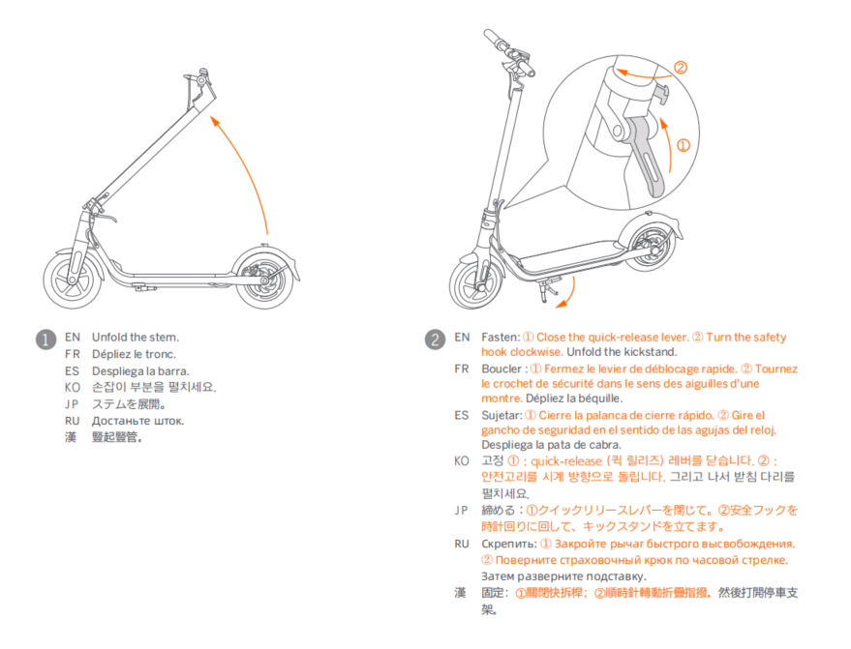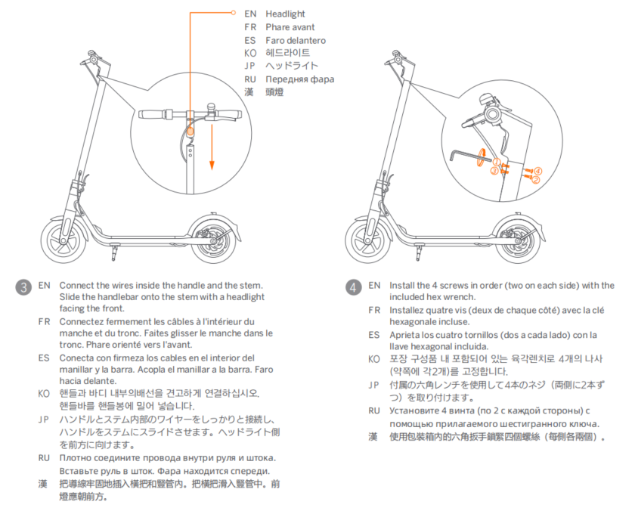

2.1.2 How to adjust disc brake？
Too tight：Loosen the screw with a 4 mm hex wrench. Decrease the brake cable and tighten the screw.
Too loose：Tighten: Loosen the screw with a 4 mm hex wrench. Increase the brake cable and tighten the screw.

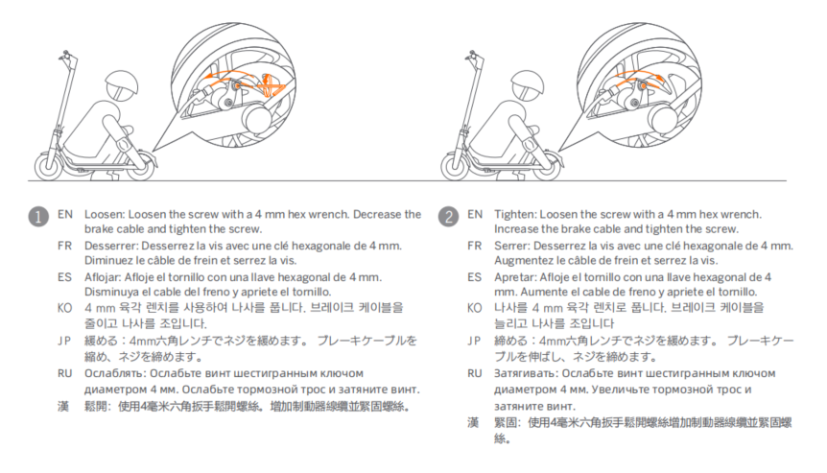

2.1.3 How to inflate scooter?
1.Unscrew the valve cap；
2.Connect the valve stem extension to the tire valve stem；
3.Connect valve stem extension with pump ；
4.Inflate tire until 45~50psi，stop inflate and remove valve stem extension，install valve cap
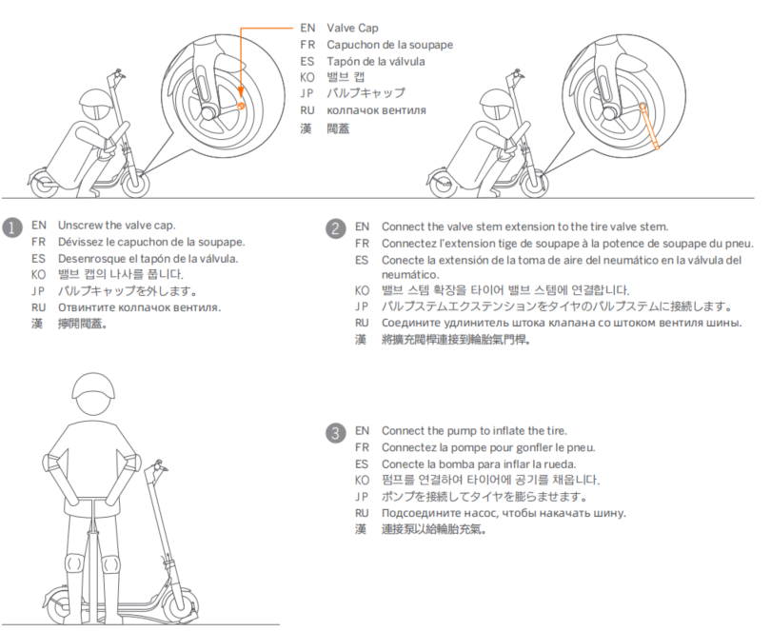

2.1.4 How to solve brake disc friction problem？
① Loose two screws that fix brake disc base（No need to loose it completely），move brake disc base left and right，rotating the rear wheel and check the gap and the friction condition of the disc，until brake disc pad is in middle of brake disc base，fix two screws。Rotating the rear wheel and test again whether friction disappeared
②If disc brake pad is deformed, you need to apply for after-sales support to replace the disc brake disc
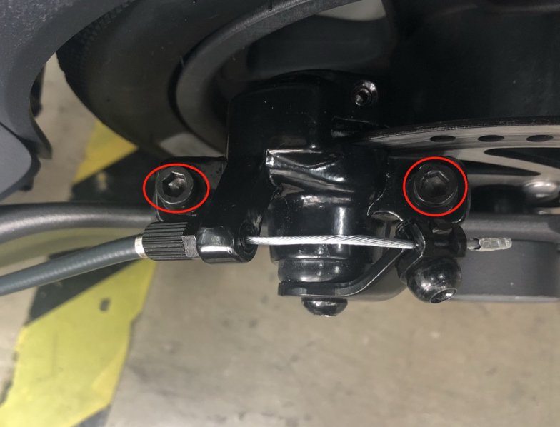

2.2 How to use：

2.2.1How many speed mode?How to change speed mode？What is MAX speed？
Total 3 speed mode，ECO、standard mode（D）、sport mode（S）。
Speed mode change method：Power on status，double click power button change speed mode；
Notes：Different mode has different Max speed on each speed mode
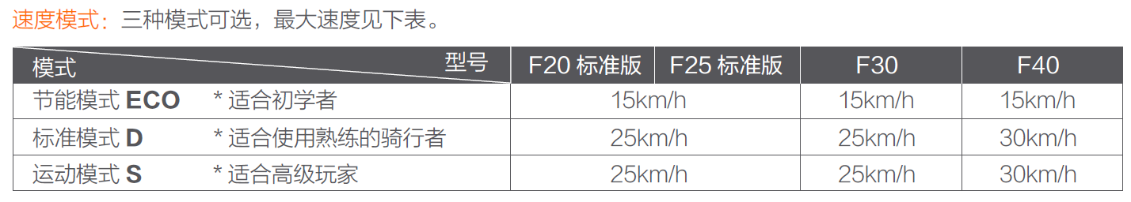

2.2.2 What is difference between different speed mode？
There are three mode indicator light on dashboard，different mode has different Max speed.Below is three mode indicator light status：
ECO：ECO indicator light up，throttle output is smoother than standard mode，suitable for beginners to be familiar with riding
Standard mode：“D”indicator light up，throttle output is smooth；
Sport mode：“S”indicator light up，output is strong，It is recommended to consider using it after mastering the riding skills
Notes：When the riding speed more than 20km/h, the rider must wear adequate protective measures

2.2.3 How to ride scooter?
1. Gliding：Stand on the foot board with one foot and push off with the other foot to start gliding.
2. Speed up：Put both feet on the foot board and stand stably. Press the throttle to speed up when you are balanced.
（gliding speed more than 3km/h）
3. Slow down：Slow down by releasing the throttle and squeezing the brake lever.Higher energy recovery level can helps slow down
4. To turn, shift your body and turn the handlebar slightly.
As below picture show：
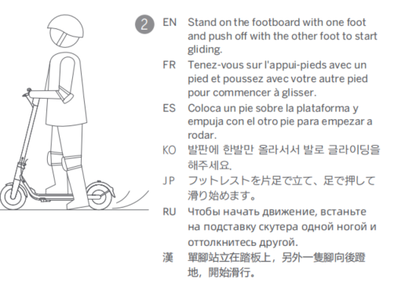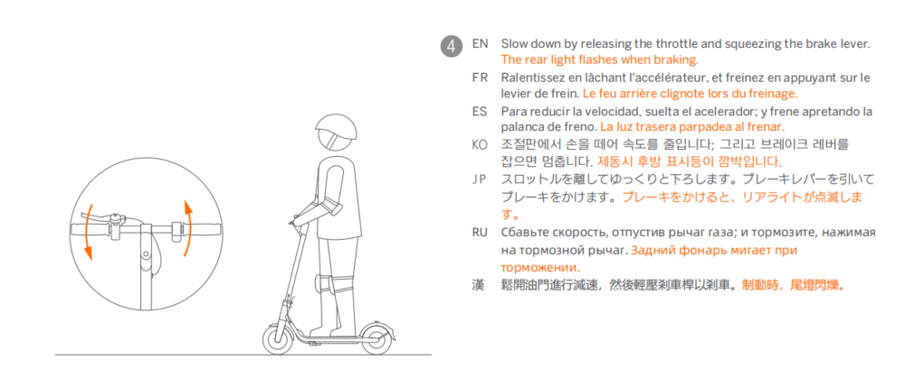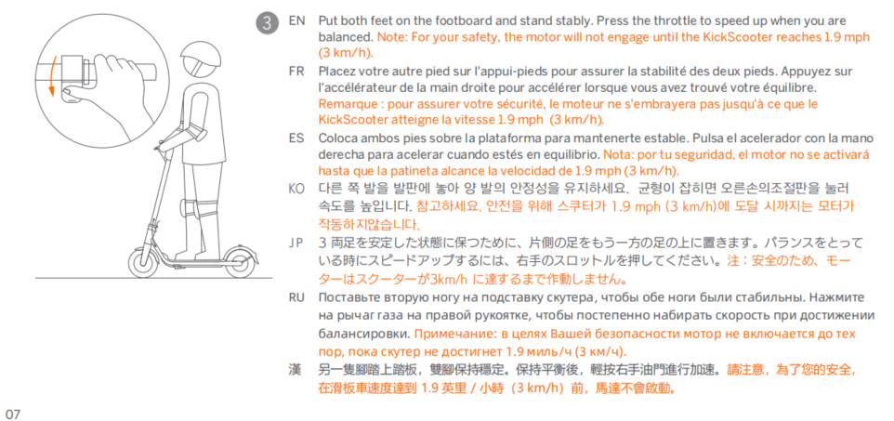
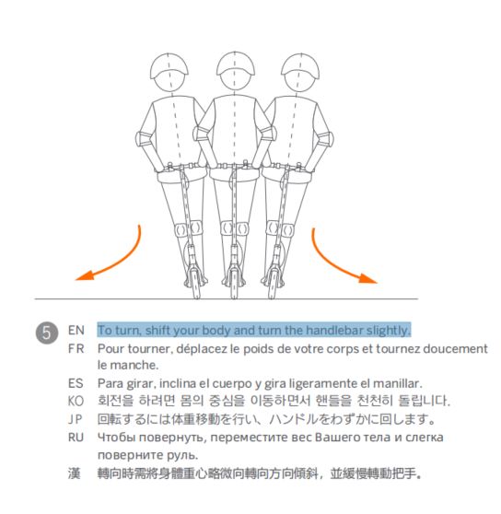

2.2.4 How to activate scooter?
The brand new scooter is inactive，limit speed 15km/h，there will be a buzzer after powering on.Before first use，you must use Segway-Ninebot APP activate your scooter.The activation method is shown in the figure below:
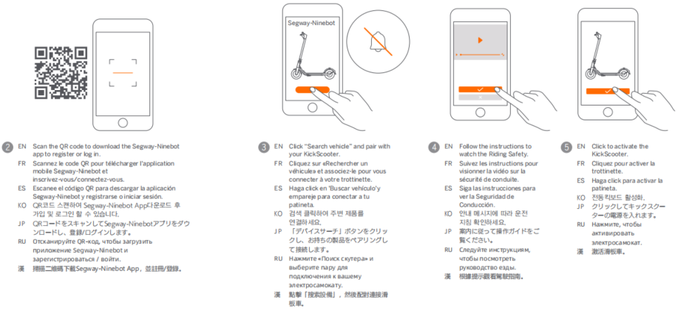

2.2.4 Does it have to be activated to use scooter？
When the scooter is not activated, the speed limit will be 15km/h and there will be a buzzer prompt after turning on the scooter. It is recommended that assembled and activate scooter before riding

Function introduction

3.1 Light

3.1.1 How to open and close headlight
Power on status,click power button one time open/close headlight

3.1.2 How to open/close taillight?
Power on status,click power button one time open/close taillight

3.2 Power on/off、brake、charge

3.2.1 How to power on?
Install handlebar，short press power button on dashboard，a beep of "di" is heard and the display shows normal，and scooter already power on

3.2.2 How to power off?
Long press the power button on the dashboard for three seconds，a beep of "di" is heard and the display shout down，and scooter already power off

3.2.3 How to use brake
Squeeze the brake lever on the left hand side to brake

3.2.4 How to charge?
1.Charge port is on front of frame pedal，open charge port plus
2.Connect charger with charge port，then connect charger with power.Charger indicator light show red mean scooter is charging
3.Charge finished,lock charge port plug
Charge indicator light：Red（Charging）；Green（Charge finished）
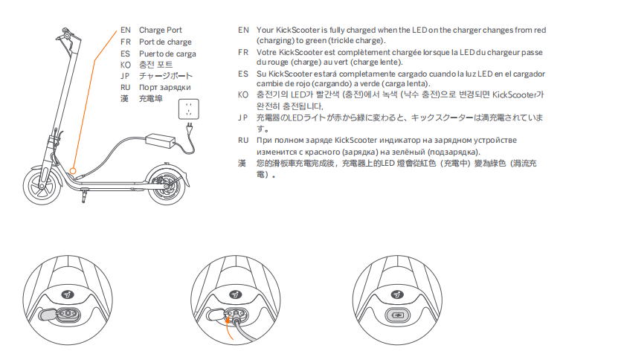

3.3 Folding and Carrying

3.3.1 Folding
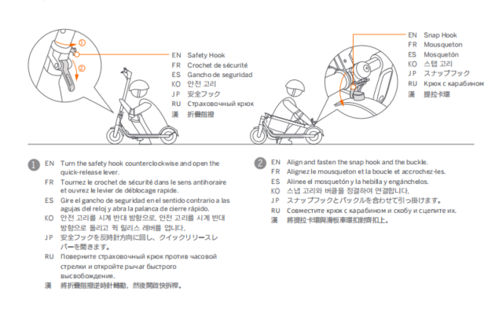

3.3.2 Unfolding
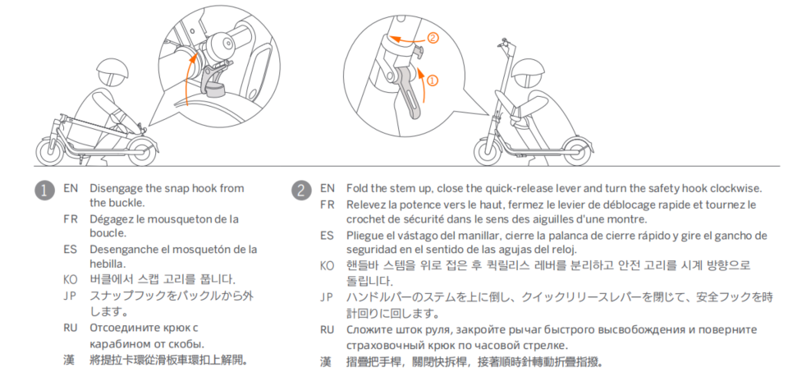

3.3.3 Carrying
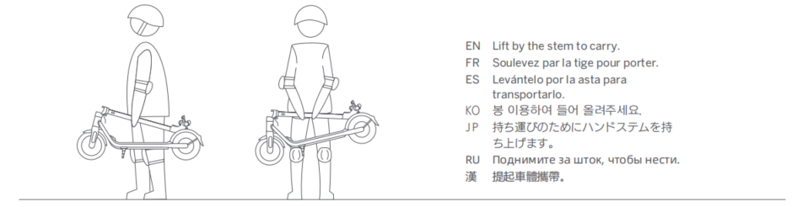

3.4 APP

3.4.1APP How to connect APP?
1.Download and install “Segway-Ninebot” APP on phone,and log in/register
2.Open APP and power on scooter，click“Add device”or up right concern“+”add device，find scooter and click“→” connect
3.Follow APP instruction，press power button to pair Bluetooth.
4.When dashboard always show Bluetooth logo and APP interface show this scooter,mean already connect successfully

3.4.2 How to open cruise mode?
Swipe from bottom to top on the main interface→『Cruise mode』→『Yes』→cruise mode button change to dark gray
Trigger cruise mode：During riding, press and hold the throttle finger for 5 seconds. After hearing the "Beep" sound, it succeeds.
Exit cruise mode ：Press brake or throttle can exit cruise mode

3.4.3 How to adjust energy recovery?
Energy recovery：Swipe from bottom to top on the main interface→『Energy recovery』→『Energy recovery level』 setting
Energy recovery level：“Weak、Medium、Strong”

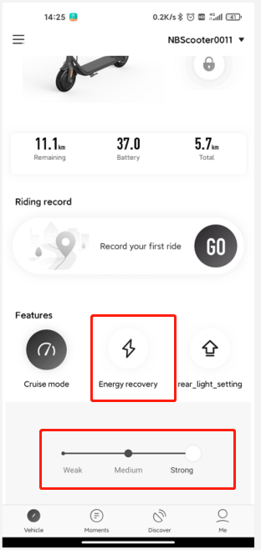

3.4.4 How to use APP lock and unlock scooter
Lock：On interface,slide blue lock to dark lock，lock change to『black lock』.Connect APP，if scooter had been locked，APP will show warning when move scooter
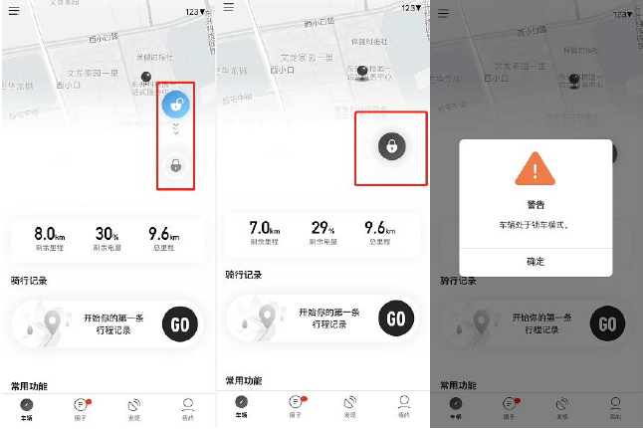
Unlock：Click『Black lock』
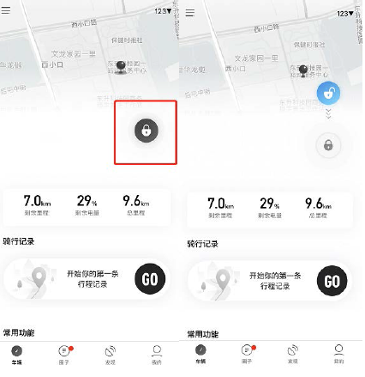

3.4.5 How to bind scooter?
Click『Left Column Button』→『Unbind』→『Enter phone number』→『confirm to unbind』
Note：To unbind the device, you need to use the mobile phone number or email account you used to log in to receive the verification code.。
After unbinding the device, you will be cleared as the owner of the vehicle. At the same time, you will not be able to view historical information such as the vehicle's riding records.
。
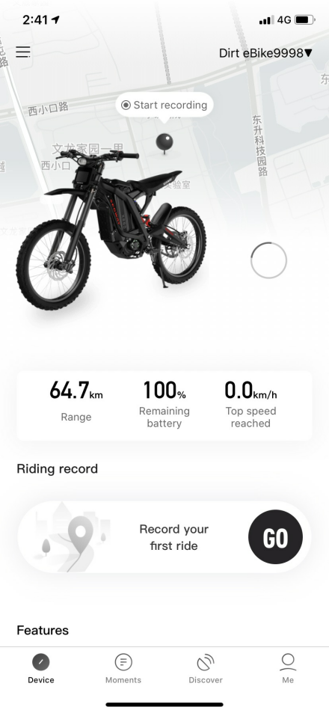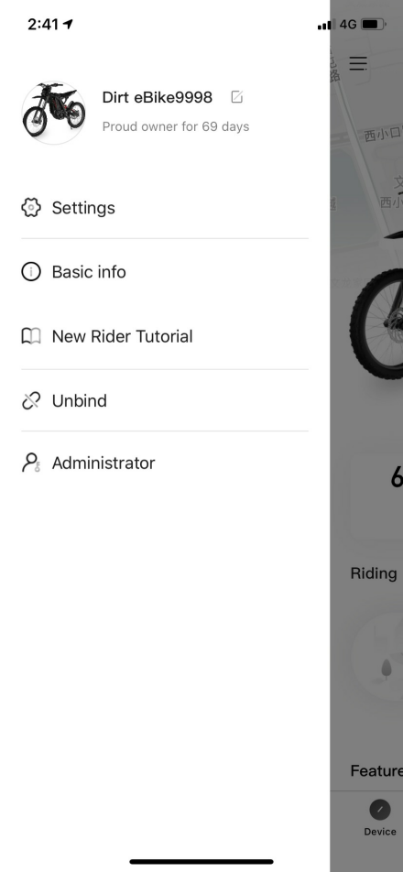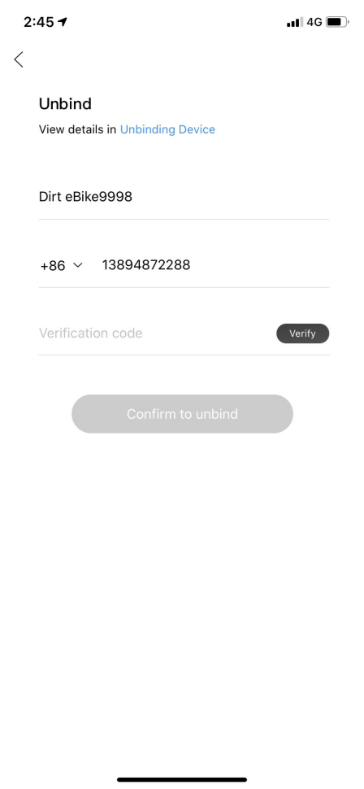

3.4.6 How to do owner certification?
Owner certification：When a vehicle is bound to the vehicle for the first time or after being unbound, the vehicle will automatically conduct certification, i.e. the owner certification.
。
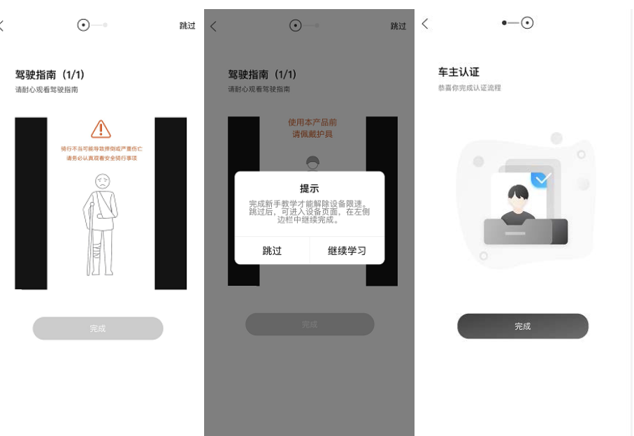

4. Common problem classification

4.1 Frame problem：

4.1.1 What kind of tires are used in Ninebot F series scooter？
The front and rear wheels of the F series use pneumatic tires, made of rubber, with inner and outer tires, has good shock absorption performance

4.1.2What material is Ninebot F series scooter？
Fender is made of PC

4.1.3 Can the rear fender of the Ninebot F series scooter be stepped on or braked?
No，F series scooter’s rear fender hasn’t brake function，not allow step

4.1.4 What is the safe value of the turning angle of Ninebot F series scooter？Is it dangerous to turn too fast?
Scooter left or right max turning angle is 60°.When riding a turn, you need to slow down and then make a turn. The faster the speed, the less sharp the turn.If angle exceeds 60°, there may be a problem with the anti-rotation film, and you need to contact after-sales for testing

4.1.5 What does the red thermometer on the dashboard mean?
The red thermometer icon on the dashboard is a temperature reminder: it means that the battery temperature has reached 55°C or lower than 0°C. At this time, the scooter's acceleration ability is weakened and the scooter may not be able to charge. Please leave the scooter to room temperature before charging. Confirm whether the red thermometer icon disappears, if it disappears, the scooter is normal, otherwise contact the after-sales service for repair.

4.1.6 Can Ninebot F series scooter be ridden on public roads or other public places, and the precautions?
1.1. An electric scooter is a sport and entertainment tool, not a means of transportation, please do not ride in public areas. But once you ride it into the public area, it will also have the attributes of a vehicle, so there are also possible safety risks for all vehicles. Riding in strict accordance with the instructions in this manual will protect you and others' safety to the greatest extent, and ensure compliance with national and provincial and municipal traffic laws and regulations.
2.At the same time, you need to understand: Once the electric scooter is driven on public roads or other public places, even if you fully follow this safe riding guide, you may also face risks caused by illegal driving/improper operation of others or vehicles. Just like walking or riding a bicycle, you may also be injured by other vehicles; like all vehicles, the faster you ride an electric scooter, the longer the distance required for braking. Emergency braking on some slippery ground may also cause wheels to slip. And lose balance or even fall. Therefore, it is very important to be vigilant, maintain an appropriate speed, and maintain a reasonable and safe distance from other people and vehicles during riding. When driving into unfamiliar terrain, stay alert and drive at a low speed.
3.Please respect the pedestrian's right of way when riding. Avoid frightening pedestrians, especially children. When passing behind a pedestrian, remind the pedestrian and slow down when passing. Pass as far as possible from the left side of pedestrians (applicable to countries where vehicles drive on the right). When facing pedestrians, stay on the right and slow down

4.1.7 What’s problem with scooter when it keep make“Di” voice ？
1. Connect APP and check whether scooter had been locked，unlock scooter on APP if scooter had been locked
2. Check if scooter is activated，use APP activate scooter if scooter still not be activated
3. If you connect to the APP and found alarm fault code on the dashboard, please contact the after-sales service。

4.1.8 Throttle does not spring back, how to solve it?
Check whether there is any obstruction between the grip and the finger dial assembly, which makes throttle can ‘t spring back，if gap is small or there is obstruction，need pull out grip，keep distance about 5mm，as below picture show：
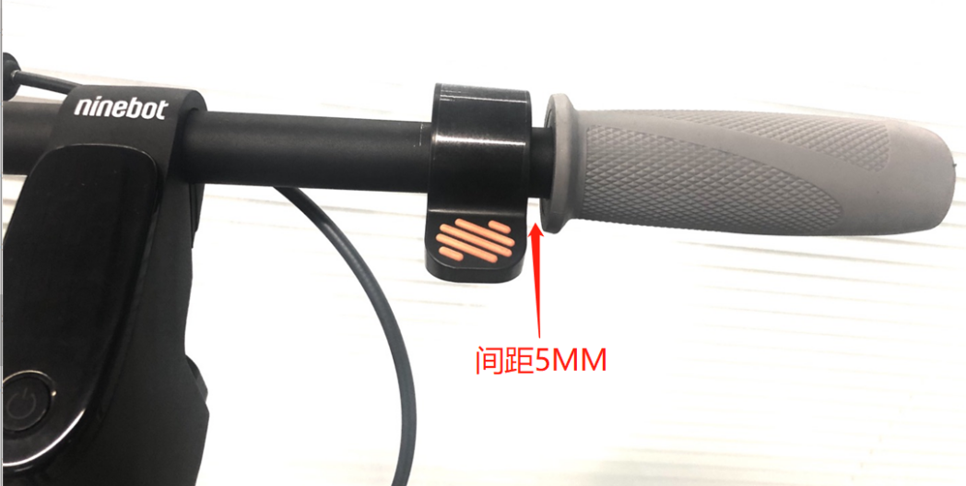

4.1.9 What causes the failure of brakes? How to solve it?
1. Hold the brake lever and observe whether the brake disc base at the rear wheel can clamp the disc brake normally. If the clamp is not tight or too loose, you can debug and tighten the disc brake to solve the problem.
2. If error code occurs or the disc brake is damaged, please contact after-sales service for repair

4.1.10 What causes the failure of throttle? How to solve it?
1.Check scooter power on/off status,is the battery fully charged?
2.Check whether there is any response after pressing the throttle when the slide speed exceeds 3km/h
3.If the error code 14 or other unknown fault occurs, please contact after-sales service

4.1.11 How to solve the problem of lights?
The main problems of lights are as follows：
1. Taillights can not turn on: when the headlights are not turned on, it may be that the taillights in the APP are not set on taillight always on, and the APP needs to be connected to scooter to set on taillight always on. If the headlights are turned on or set to be always on, they need to be turned on. Contact after-sales repair；
2.If headlight is abnormal (including not bright and dimmed), please contact the after-sales service for repair

4.1.12 What is the problem that dashboard does not display？
Please check whether the connection is well connected. If the connection is good and there is no problem, you need to contact the after-sales service to report for repair.

4.1.13 How to solve stem shaking？
一、Use hand shakes stem back and forth, and it is normal to feel a shaking feeling, because from the handlebar to the frame position, it is a long distance between structure and connect point, so there will be a shaking feeling.
二、If stem shaking is relatively large and there is a gap in the connection, you can solve it by the following methods：
1. Check whether the screws at the connection between the handlebar and the stem are loose. If it is loose, you need to use a 3mm Allen wrench to tighten the screws.
As show in picture：
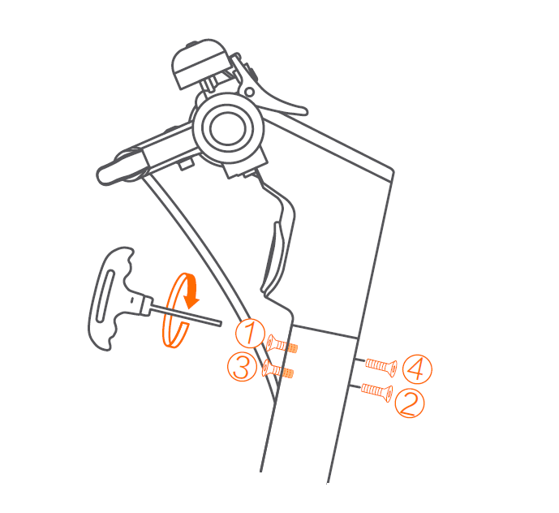
- Tighten folding stem screw：
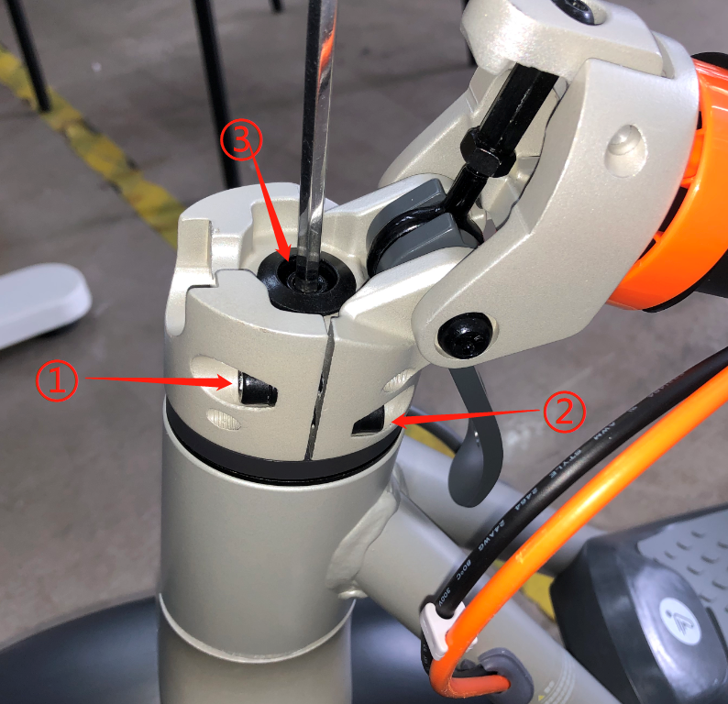
3.If there method can’t solve problem，please contact after-sales service for repair

4.1.14 How to solve the problem that the stem screw cannot be installed？
①When installing the stem screws, align the mounting holes first.
②）First use wrench to pre-tighten each screw , follow the order (as shown in picture)
③Tighten 4 screws

4.1.15 Will screen be darker after turning on the light?？
Screen will not be darker after turning on light
4.1.16 How to solve if found scratches on new scooter？
There are two situations：
1.There are slight abrasion marks at the upper part of the handlebar joint. This is caused by the matching test between the upper part of the handlebar and the scooter body before the new car leaves the factory. Please don’t worry.
2.There are scratches on the exterior of the vehicle, which are caused by friction during transportation

4.1.17 How to solve the front wheel crooked？
Front wheel skew refers to the situation where the tire and the handlebar are not in a straight line. You can clamp the front wheel with your feet and fine-tune the handlebar in the opposite direction. It is recommended to apply for after-sales treatment directly if you encounter serious skew.

4.1.18 Why the actual range cannot reach the range show on the page？
The page shows a typical range，under full charge condition，75kg load，25℃ temperature,60% of max.speed on average on pavement
In actual riding, the riding speed, the number of starts and stops, and the ambient temperature will affect the range. So your actual cycling range is different from the range marked on the page

4.1.19 How to solve if scooter can not turn on？
1.First check whether goose head cable is well connected
2.Make sure charger is working, charge the scooter and try to turn it on after charging
3.If it still cannot be turned on, you need to contact after-sales service for repair

4.1.20 What is IP rate of Ninebot F series scooter？Can I ride in rain, snow, hail, and fog?？
F series scooter has IPX5；Although the body has a waterproof design, long wading is not recommended. Long wading may cause water ingress and malfunction; and for the user’s personal safety, it is prone to danger in bad weather, so riding is not recommended

4.1.21 Where is serial number？
There are 3 methods to find SN：
1.You can found SN label on side of out box
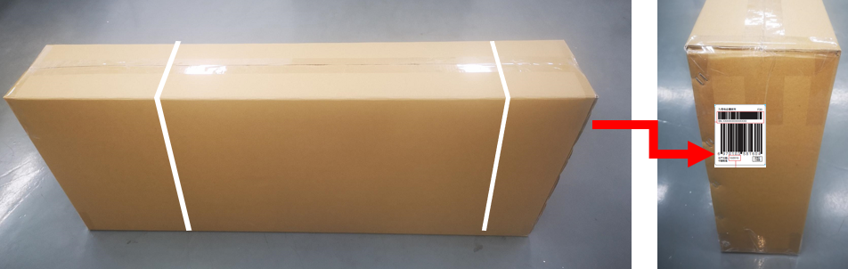
2. SN label on bottom of scooter frame
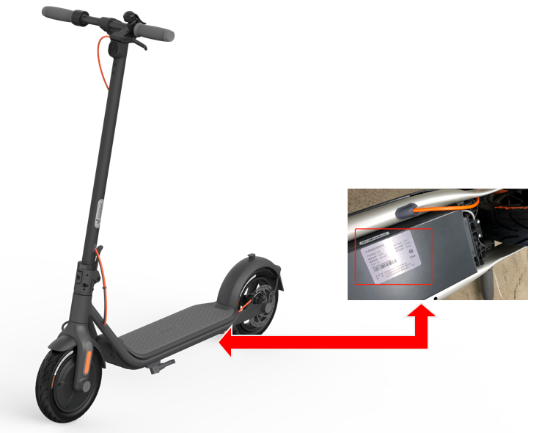
3.Connect App：Click『Left sidebar button』→『Basic info』→『Series No』
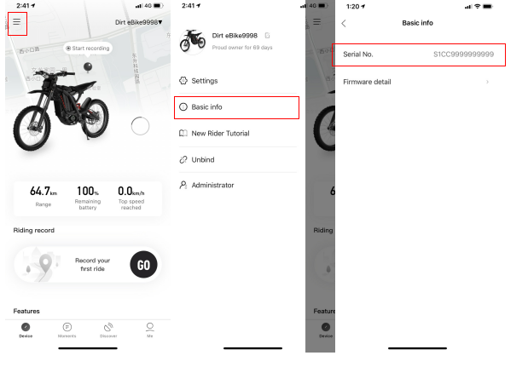

4.1.22 Does the F series scooter support the installation of external batteries?
Can not support

4.1.23 What is appearance difference between different model F series scooter?
Mainly the color difference of some parts. F20 and F25 are basically the same in appearance, and the appearance is mainly gray and black; F30 compares the appearance of F20, and the brake cable turns orange; F40 compares the appearance of F20, brake cable, wheel stroke, and stem buckle all turn orange .

4.1.24 What information can be displayed on the dashboard？
Speedometer,speed mode,battery level,temperature warning,error notification,headlight
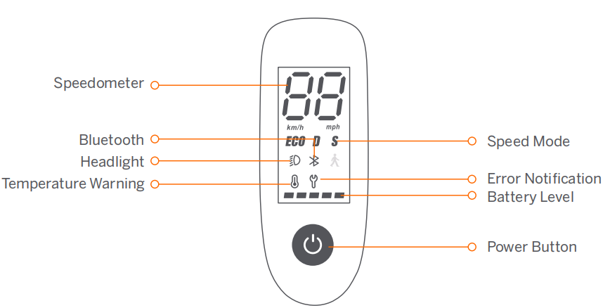

4.1.25 What does battery level indicator mean？
There are 5 battery indicator lights on dashboard. Each light represents a 20% power state. The battery indicator has two states: always on and flashing. When the power of each grid is 10%-20%, the indicator light is always on; when the power is less than 20%, the last grid will display red, indicating that the power is extremely low at this time, please charge in time (the last one is flashing red, and the remaining indicators White)

4.2 APP function：

4.2.1 How to upgrade firmware？What's the use of firmware upgrade?
Firmware update：Click『Left sidebar button』→『Setting』→『Firmware update』→『Check for update』
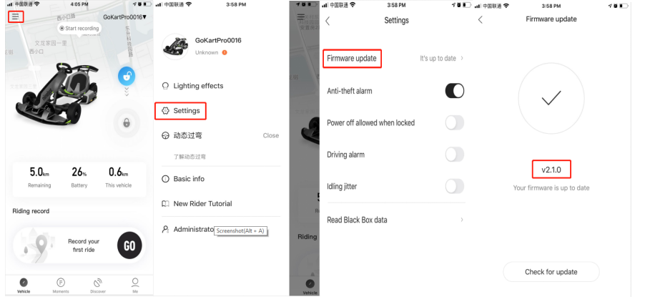
Upgrading the firmware will improve scooter and fix related bugs at the same time

4.2.2 What is the longest distance for Bluetooth connection？
About 10m

4.2.3 How long will the F series automatically shut down?？
Under normal circumstances,scooter will automatically shut down in silence for 5 minutes; when the APP locks the car, it will automatically shut down in 1 hour

4.2.4 How to solve if can't connect to the scooter after lock scooter？
1.You can change to another phone and try to search and connect again, and then unlock scooter by other phone after successfully connecting
2.Scooter will automatically shut down and unlock after one hour

4.2.5 How to solve if scooter can not connect APP?
①Check the Bluetooth status on the display after the vehicle is turned on, flashing is to be connected
②Check whether the APP has authorized Bluetooth, network, GPS positioning and other permissions on the phone. You need to open the relevant permissions before you can connect to the APP
③You can change the mobile device or the network environment to try
④Try to update to the latest version of APP
⑤The above investigation still cannot solve, need to apply for after-sales repair

4.3 Power problem：

4.3.1 Is the display always on and cannot be turned off when charging?？
In the charging state, the display will show the charging state, and it can be turned off manually to turn off the screen display during charging.

4.3.2 What is the charging temperature range of F series batteries？Why can't charge in high temperature or low temperature environment？
九号电动滑板车F系列电池组充电温度范围：0℃—40℃，电池组温度过高或者过低会自动保护而无法充电。待静置至40℃以下或0度以上恢复正常，此情况无需报修。如果恢复到充电温度范围仍然无法充电可以报修。F series battery pack charging temperature range: 0℃-40℃, the battery pack will be automatically protected and cannot be charged if the temperature is too high or too low. When temperature get 40°C or above 0°C, it will return to normal. In this case, there is no need to report for repair. If it is restored to the charging temperature range and still unable to charge, you can report for repair

4.3.3 Is it normal that speed decrease when power decrease?
Normal. In order to extend the riding mileage as much as possible, the maximum speed continues to decrease with the decrease of power, and the maximum speed of the scooter will gradually decrease when the power is low. In addition, when the battery is low, the power will obviously be weakened, and it ca recovery after fully charged.

4.4 Accessory problem：

4.1.1Accessory packing list
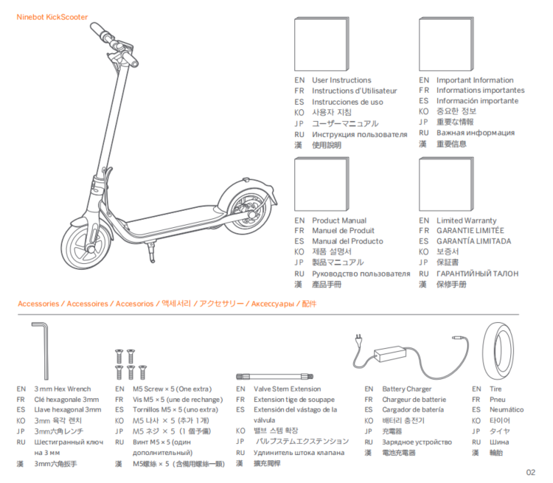

4.1.2 Where is screw package？
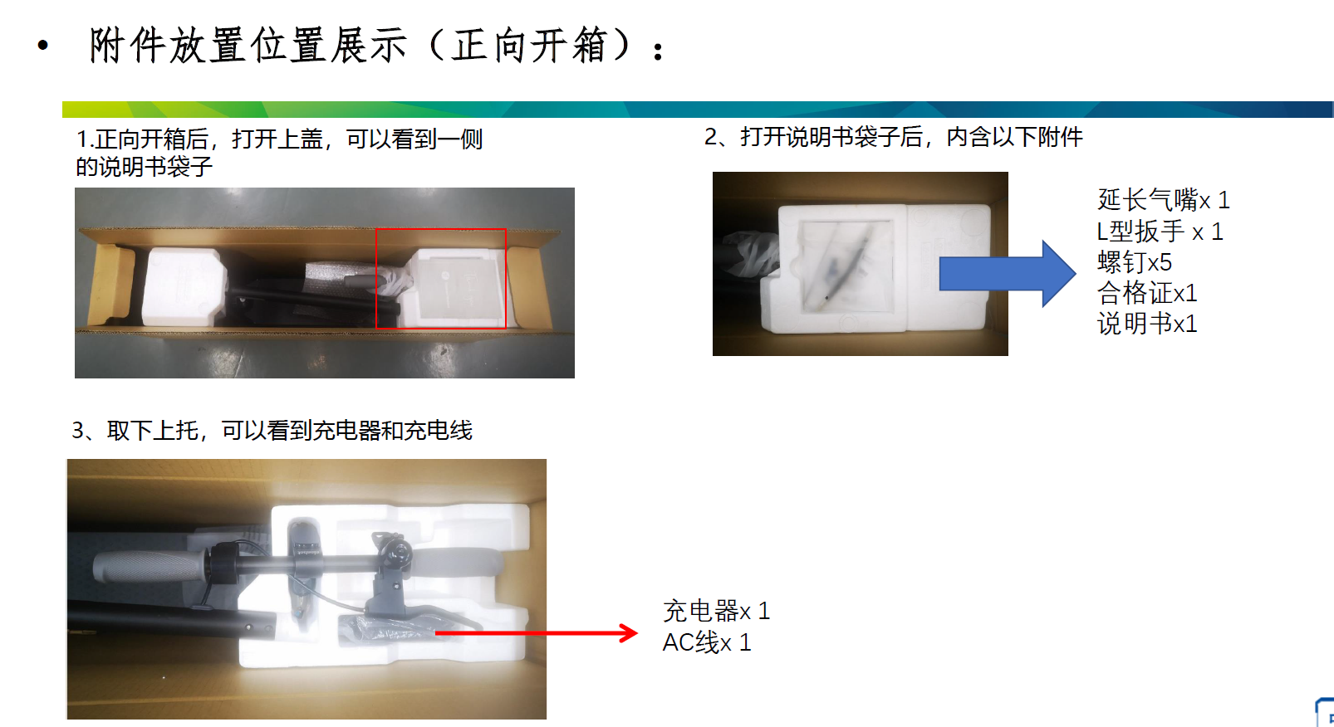
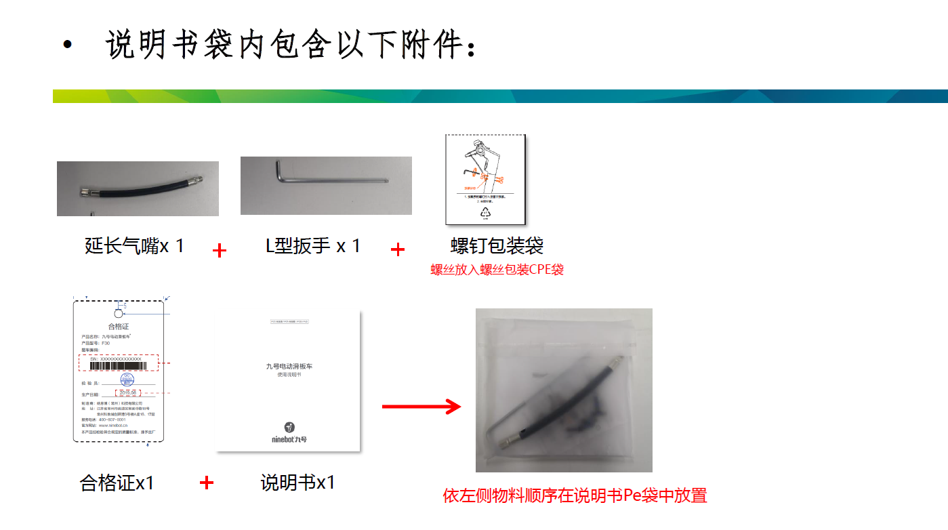

4.5 Battery：

4.5.1 What type of battery does F series scooter use? How long is the battery life？
The scooter uses 18650 ternary lithium batteries. After 500 cycles of charging and discharging, the battery capacity will not be less than 70% of the rated capacity. It is recommended to charge when the battery is about 10% remaining to avoid over-discharge, which can prolong the battery life.。

4.5.2 Can F series scooter battery be disassembled by myself?
Battery can be disassembled by yourself,you will lost warranty if you disassembled by yourself

4.5.3 How to judge that F series have been fully charged during charging？
Charger indicator: When charging, the red light is always on; when fully charged, the green light is on

4.5.4 How to solve if scooter can be charged？
Need to follow the steps below to trouble shoot：
1.Whether the contact is bad: re-plug the connections on both sides of the charger to see if it can be resolved；
2.Check whether the charger is faulty: plug the charger into the power supply, do not connect to the car body, observe whether the indicator light of the charger is normally on (green), if it does not light, it means the charger is faulty, you need to contact the after-sales service for repair；
3.Check whether the charging status indicator of the charger is red, if it keeps showing green and cannot be charged, you need to contact the after-sales service for repair

4.7 Error code list：
Check method：1.Check on dashboard；2.Check on APP
Ninebot F series scooter error code
Fault code calculation method (according to the buzzer alarm sound): the buzzer has a long "di" sound as 10, and a short "di" sound is 1, and the sum is the fault code
error code | Error phenomenon and solution | Malfunction part
10 | Dashboard and control board communication abnormal，check connected cable | Dashboard、Control board
11 | Motor A phase current abnormal ，check control board | Control board
12 | Motor B phase current abnormal ，check control board | Control board
13 | Motor C phase current abnormal ，check control board | Control board
14 | Throttle hall abnormal，check electric throttle、dashboard and connected cable | Dashboard、Electric throttle
15 | Brake hall abnormal，check electric brake、dashboard and connected cable | Dashboard、Brake
21 | Battery communication failed，check battery、control board、connected cable  (1.BMS communication error 2.Battery cable connect error or battery inner temperature sensor damage or control board temperature sensor | Inner battery、Control board
24 | System voltage test abnormal，check control board | Control board、Inner battery
27 | Control board password error，change control board | Control board
35 | Unit has default serial number，change control board | Modify the default serial number、Control board
37 | Simulating the whole machine report error 37 | Charge port error or charger line error
39 | Battery temperature sensor abnormal | Inner battery

4.8 Maintenance item：

4.8.1 How to clean the F series scooter？
Wipe the main frame clean with a soft damp cloth. If there are stains that are difficult to clean, you can use toothpaste to apply and repeatedly scrub with a toothbrush, and then clean with a soft damp cloth

4.8.2 What need to pay attention to when cleaning F series scooter？
Before cleaning, please make sure that the scooter is turned off, and the charging cable has been unplugged and the rubber cover of the charging port has been tightened, otherwise the electronic components may be damaged. Do not use alcohol, gasoline, kerosene or other corrosive and volatile solvents to clean your scooter. These substances may damage the appearance and internal structure of the car body. It is forbidden to use pressure water guns or water pipes to spray scouring。

4.8.3 What need to pay attention to when storing the F series scooter？
1.When not in use, please store the scooter in a cool, dry place. Please do not store the scooter outdoors for a long time. Sun exposure and extreme temperature conditions (excessive heat and cold) will accelerate the aging of plastic parts and may reduce battery life.
2. Regarding battery storage and maintenance: a fully charged battery will exhaust its stored power after about 120-180 days of standby. In standby mode, low-power batteries should be charged every 30-60 days. Full exhaustion of the battery will cause permanent damage to the battery as much as possible. There is a smart chip inside the battery to record the charge and discharge of the battery. Damage caused by overcharging or undercharging is not covered by the warranty

5. Service Policy

5.1Limited Warranty Period
